Sentiment Analysis on Twitter Data Text Analytics Approach

Introduction
Microblogging websites tweeter have evolved to become a source of varied kind of information and playing an important role for sentiment analysis world-wide. According to statistics of twitter user (Twitter usage stats) more than 500 million tweets are tweeted everyday and this numbers are increasing . Analyzing tweets has applications in understanding how public sentiment is shaped, tracking public sentiment and polarization with respect to their views and issues and understanding the impact of tweets from various entities.
Motivation :
A good number of studies already available, in which the messages of social platforms are
considered and interpreted. Every hour few millions of messages published by users. This implies to an extremely high amount of data, called Big Data. With velocity, variety and volume of these big data, there are new technologies required for analyzing it in an efficient way. Many of them examine objectives like popularity of events or sentiments in the messages. One of the most popular social networks currently is Twitter. The specialty of it is the micro blogging aspect. All posted messages of Twitter have a limited number of characters. Each message, which is called tweet, can contain maximally 140 characters, so that the users need to adapt their language, which results in a high occurrence of abbreviations. Besides the written content of a tweet, Twitter stores a lot of additional information like the publisher, user mentions in the text, hashtags, language and many more.

Organizations in entertainment area like movie producers ,game developers uses twitter data for sentiment analysis most to understand how the public feels about their product something at a particular moment in time and also to track how those opinions change over time. Sentiment analysis helps them to take decision about their future projects. Now one challenge is to build technology to detect and summarize an overall sentiment.
Goal of the project :
In this project, we look at one such popular micro blog "Twitter" and do the sentiment analysis of Marvel Entertainment's (www.marvel.com) movie product Ironman3. We will look at public sentiment during the days leading up to and immediately following the recent release of the movie then analyze the twitter data tweeted from different location then classify and visualize the results. It is expected that this analysis outcomes will help the organization to take the decision "making a sequel of this movie will be a massive block bluster" and help to predict how these sentiment data could used for better promote the next movie’s launch. This project will utilize state of the art big data tools and proven text analytics algorithms. Most of our data analysis has been For twitter data collection we use twitter API

Dataset
In this project, for the simplicity of the analysis we are considering 200 tweets. These tweets are collected from Twitter through twitter API. We can also collect/download these data using Python .
The overall process of data collection is given below.

Twitter Authentification:

We can't directly pull tweets from the twitter. To do so twitter comes with OAuth handshake . It is necessary for every request we do, we have to verify our app.

First we need to create an app at Twitter. To do that we got to https://dev.twitter.com/ and log in with our Twitter Account. Then we created an application (Sentiment Analysis/mzkarim).

Clicking on Create we´ll get redirected to a screen with all the OAuth setting of our new App. The application authentication pages look like following .
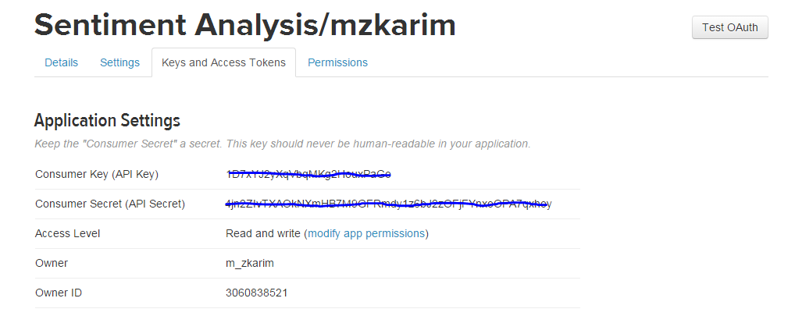
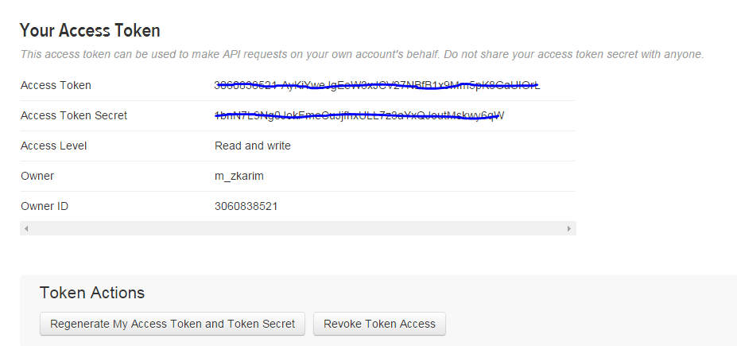
For data analysis we use R . Accessing twitter data in R requires to install some packages. First we installed these packages and then set up twitter api to work on r environment. To do so we need to write the following codes in R .
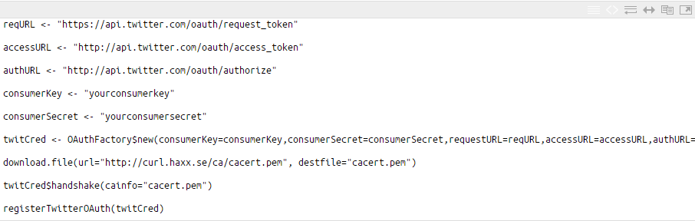

We have to replace "our consumerkey" and "our consumersecret" with the data provided on our app page on Twitter.

The command twitCred$handshake(cainfo=”cacert.pem”) will ask to go a certain URL and enter the PIN we receive on this page.
Collecting Twitter Data :

To get the tweets we use searchTwitter( ) function. The following code in R provides our required data :
tweets = searchTwitter(' #Ironman3', n=200, lang="en")
This makes twitteR get 200 tweets with the keyword #Ironman3 with only English language in it.

Approach
We mainly used four steps to complete this project. It involves the following ,

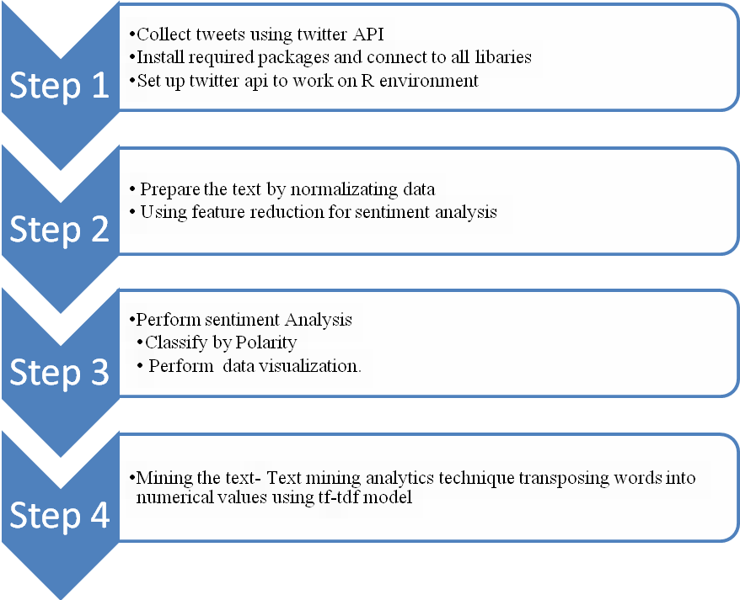
Step 1: Data Collect
First, we collect tweets from twitter related to "Ironman3" movie. We use twitter API to download these tweets. We installed required packages in R and connect to all libraries. Set up Twitter API to work on R environment.

Only content of the tweet and tweet publish timeframe have been considered here as the focus on public opinion towards Ironman3 movie. If we want to work with huge volume of data ,Python programming language can also be used and reduce the size of the raw dataset before importing to R environment.

Step 2: Preprocessing extract text
Here, task is to convert all unstructured data into structured data by removing duplicate tweets, punctuation, unnecessary whitespace, non- english characters, irrelevant links.
Step 3: Perform Sentiment Analysis
Classify the text based on polarity. Learning method has been used here to classify the text. Separate the text by classifying polarity and visualize the words with a comparison cloud. Eventually sentiment analysis speaks the overall contextual polarity of a document.
Learning method has been used here to classify the text. Use ggplot function to visualize the output of each candidate. Eventually sentiment analysis speaks the overall contextual polarity of a document.
Step 4: Estimate Tweets sentiment
Get the score of negative and positive sentiment by performing “Sentiment scoring algorithm”. Here to get the result, “Breen’s Approach” has been considered. This method is called Lexicon which is nothing but word dictionary.
Step 5: Text mining
At this stage, introduce "Text Mining" machine learning tools to determine the characteristics of the message. First, transforming text by building a corpus, that is a collection of text documents. Pre-processing text includes removing stop-words, changing letters to lower case, removing punctuations and numbers. After that, stemming words t retrieves the root from, so that words look normal. TermDocumentMatrix function provides the frequency of terms in document and also importance of the words by using performing find-Assoc. function.
Step 6: Analyze the frequency of words of each candidate
Comparison cloud and commonality cloud function have been using here to find out the words of different frequencies and the words in common from the text referring to public opinion.
Step 7: Check the accuracy of the model
Finally, text has been classified as either negative or positive by using Naive Bayes algorithm. Task is to classify new cases as they arrive, i.e., decide to which class label they belong, based on the currently exiting objects.
In summary our project has four main parts :
1. Create R Code for Twitter data Collection
This R code used for twitter data collection using twitter API. Note that to extract twitter data through twitter API we need to open an development account with twitter. The detail procedures along with twitter data collection process is shown in final report section.
2. Sentiment Analysis with classifying polarity
This is the code for doing sentiment analysis with polarity. Twitter data collected through twitter API contains unwanted symbols,numbers and many other characters that we do not need for calculating sentiment analysis. Therefore we need to clean the data set first.

Each word from individual tweet is compare with positive and negative words of a dictionary. If the first words is a positive one then it stored in pos otherwise in neg variable. the next positive or negative word is added with pos or neg counter .

By Polarity Categories :( Method- Learning Based) we first classify the polarity ( positive,negative and neutral) then using ggplot2 we create a bar chart to represent the polarity categories. The highest number of polarity represents the user sentiment about a particular subject.

3. Word Cloud:
This is the R code for making word cloud. Word cloud is a visual representation of text mining data. With text mining analysis we will search for most frequently used word. The more the word used the more bigger size the word appear in word cloud.
4. Create R Code for Tokenization
This R code is used for tokenization. We performed Unigram and Bigram tokenization to find out most frequently words used and most frequently bi gram used in tweeter data. The resultant word/words helps us to find what most of the people thinking about Ironman movie. Based on these words we can conclude a decision.

Result
Structure of the dataset before preprocessing was like
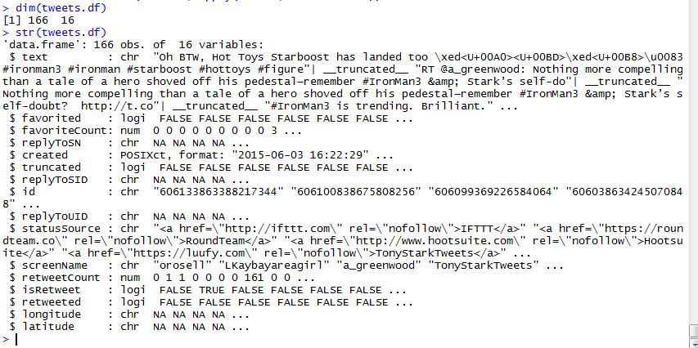
Twitter API fetched only 166 tweets with 16 variables. Observing the data we come to know that there is no information regarding geographic location ( longitude,latitude = NA) i.e. from which location these tweets were tweeted.
Sentiment analysis by polarity shows what people think about Ironman3 movie
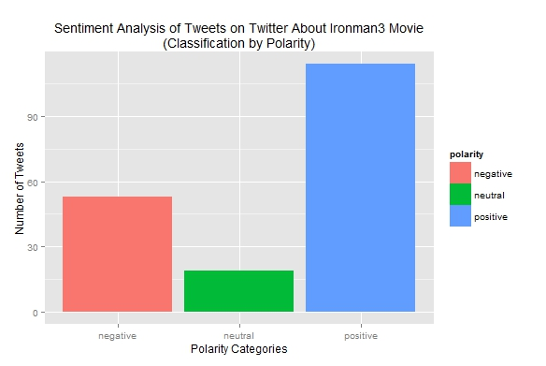
Among 3 classification by polarity positive polarity has greater positive sentiment than negative and neutral on twitter. So that we can say that, as long as most of the people says positive, therefore it will be a recommendation for marvel to go for making sequel of "Ironman" movie.

Visualize top occurring terms in term-document matrix for tweets
A common technique in text mining is using a matrix of documents terms called a document term matrix. A document term matrix is simply a matrix where columns are terms and rows are documents that contain the occurrence of specific terms within the document. Or if we reverse the order and have terms as rows and documents as columns it’s called a term document matrix.
For our project to make a Document term matrix in R , we created a file name corpus first. All we need to do is use the DocumentTermMatrix() like this:
## create corpus
corpus1 <- Corpus(VectorSource(tweets))

## create a copy of corpus to use later as a dictionary for stem completion
mycorpus <- corpus1

tdm <- DocumentTermMatrix(corpus1)
print(tdm)

We can see information on our document term matrix by using print like:
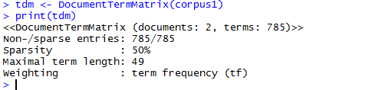

The result shows that we have two documents which contains 785 terms with 50% sparsity. Maximum length of a term is 49.

Next because we need to sum up all the values in each term column so that we can drive the frequency of each term occurrence. We also want to sort those values from highest to lowest. We used this code :
m <- as.matrix(tdm)
v <- sort(colSums(m),decreasing=TRUE)
Next we will use the names() to pull the each term object’s name which in our case is a word. Then we will build a data frame from our words associated with their frequency of occurrences. Finally we want to create our word cloud but remove any terms that have an occurrence of less than 20 times to reduce clutter in our word cloud. It is also possible to usee max.words to limit the total number of words in our word cloud. So our final code should look like this:
words <- names(v)
d <- data.frame(word=words, freq=v)
wordcloud(d$word,d$freq,min.freq=45)

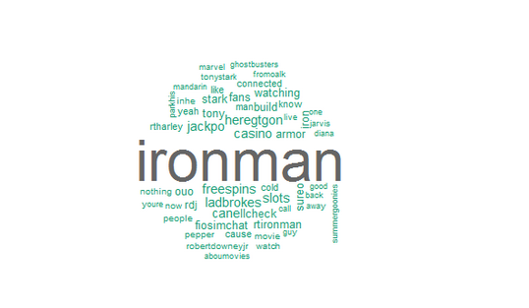
Analyzing the score :
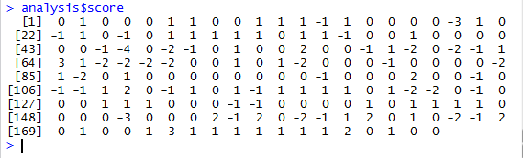
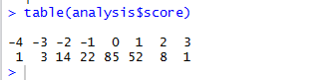
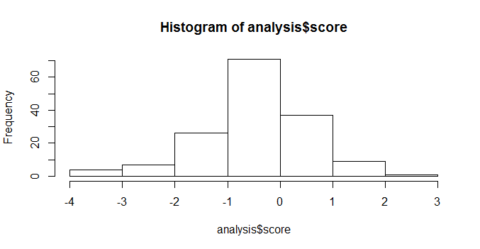
While word clouds are often used on the web for things like blogs, news sites, and other similar use cases they have real value for data analysis beyond just visual indicators for users to find terms of interest. For example if we look at the word cloud we generated we will notice that one of the most popular terms mentioned in tweets is Ironman. Doing a short inspection of our CSV document (Ironman3dataset.csv) for the term Ironman we find a lot of people mentioning the word in a variety of contexts.
Text Mining Result :
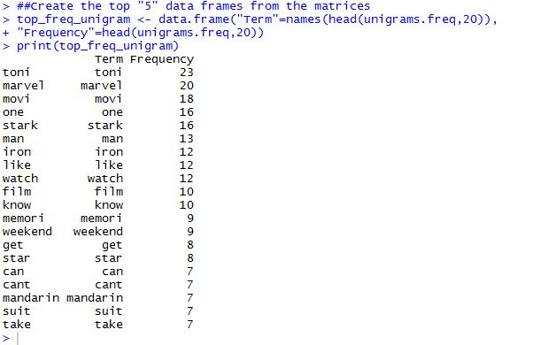
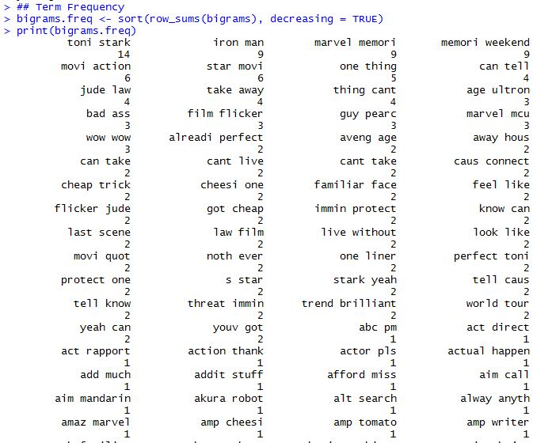
with text mining we find the most frequently used single word ( unigram) and bigram to check our analysis. From the figure above we can say that using unigram and bigram could not give us meaningful result.
Conclusion :
We presented results for sentiment analysis on Twitter. We tentatively conclude that sentiment analysis for Twitter data is not that different from sentiment analysis. We followed three approaches for our analysis ( polarity, word cloud and text mining) .After the completion of each part as well as the successful integration of those, our final project met all of our initial goals and requirements. It allows a search among large amounts of tweets and has a good scalability over all its parts (from data acquirement to data preprocessing). There are some restrictions in the Twitter APIs we used, otherwise we could easily imagine increasing the number of keywords for even more interesting results. Adding geo-tagged information could make this project even better. In our project through analyzing twitter data analysis shows that people mostly talk about positive contribution about Ironman movie. Though unigram and bigram application failed to provide any meaningful results, we will work more on this in future.
Hence the recent emerging area of interest is sentiment analysis of social issues. Now a day most of the research scholars have been working on Twitter and YouTube comments data set. To perform sentiment analysis the most and common source of data set are web pages, social web site like face book , twitter, YouTube etc. There is a vast scope for research scholars to increase the accuracy level up to some extent by using well designed sentence structure.

